Automation Framework Design for Simple UI-Based Web Application

Framework Structure (Tree Format)
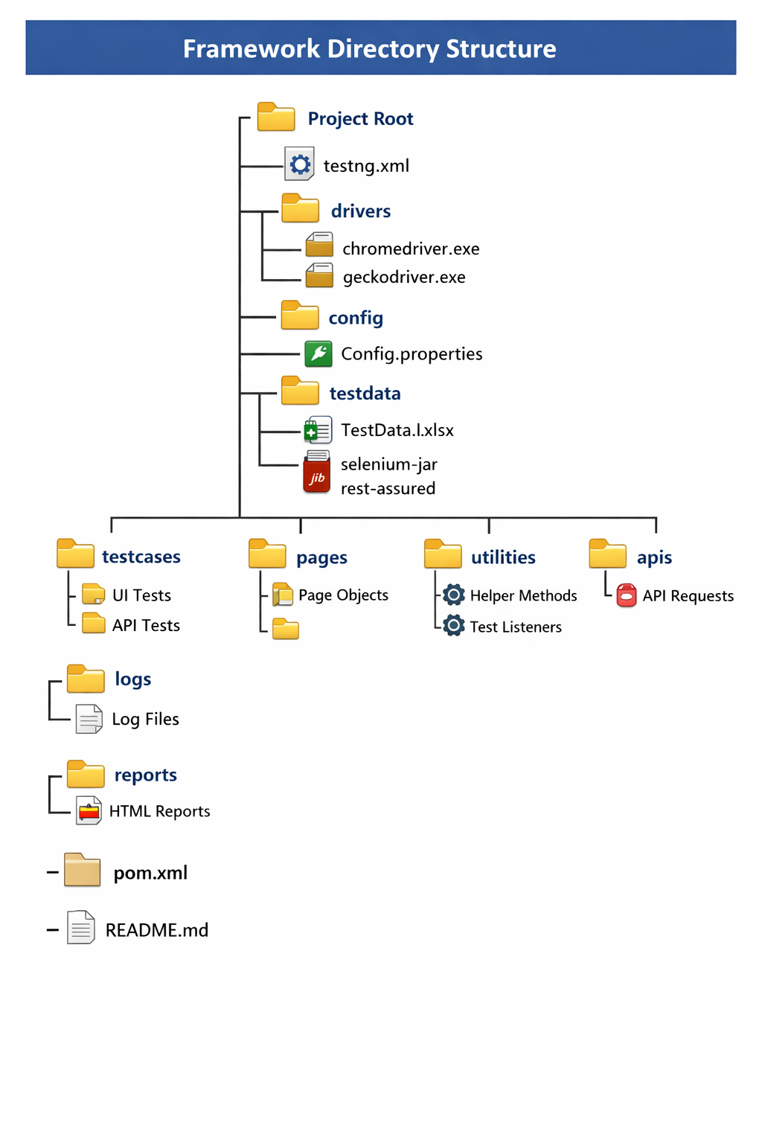

2. Framework Structure (Tabular Format)
Module / Folder | Purpose
src/main/java/base | Base classes for driver initialization, test setup, config management
src/main/java/pages | Page Object classes representing UI pages
src/main/java/tests | TestNG test classes (UI + API tests)
src/main/java/utils | Helper utilities (ExcelReader, API client, screenshot, waits, etc.)
src/main/java/listeners | TestNG listeners for logging, reporting, screenshot capture
src/main/resources/config.properties | Environment configurations (dev, QA, staging)
src/main/resources/testdata | External test data (Excel / CSV / JSON)
src/main/resources/mockdata | API mock/stub data
reports/extent-report | HTML reports (ExtentReports)
logs/automation.log | Logs generated during test execution
testng.xml | TestNG suite definition (browser, parallel execution, groups)
pom.xml | Maven project dependencies (Selenium, TestNG, ExtentReports, etc.)

This framework is modular, maintainable, and scalable, fully compatible with Java + Selenium + TestNG, supports cross-browser execution, API validation, and advanced reporting.

